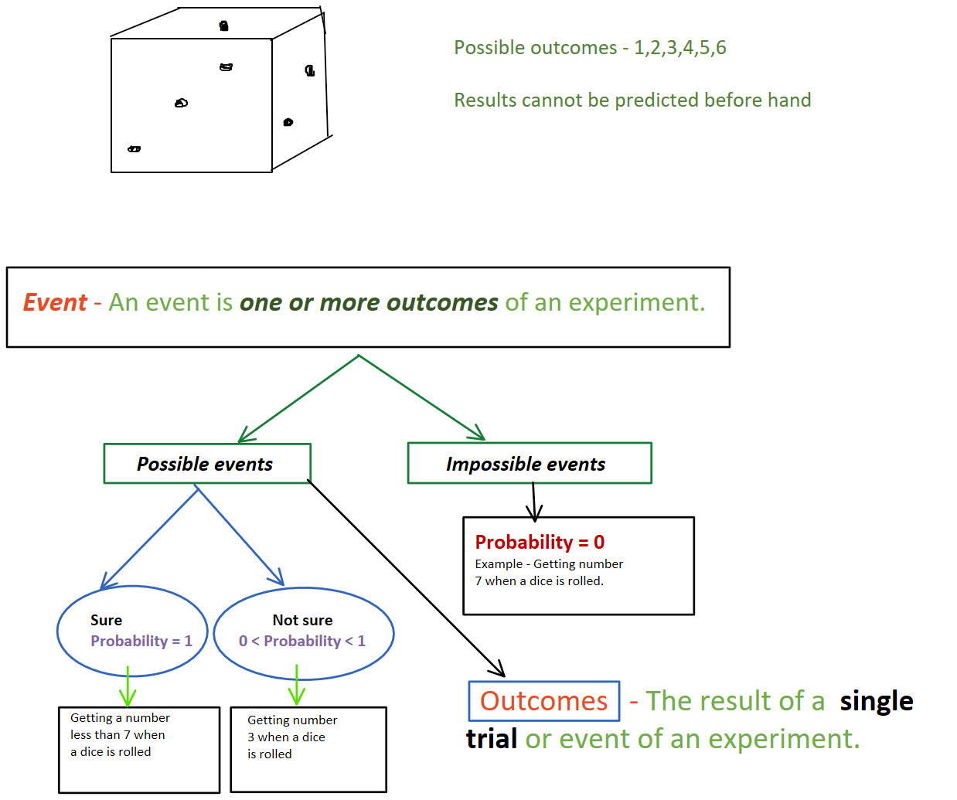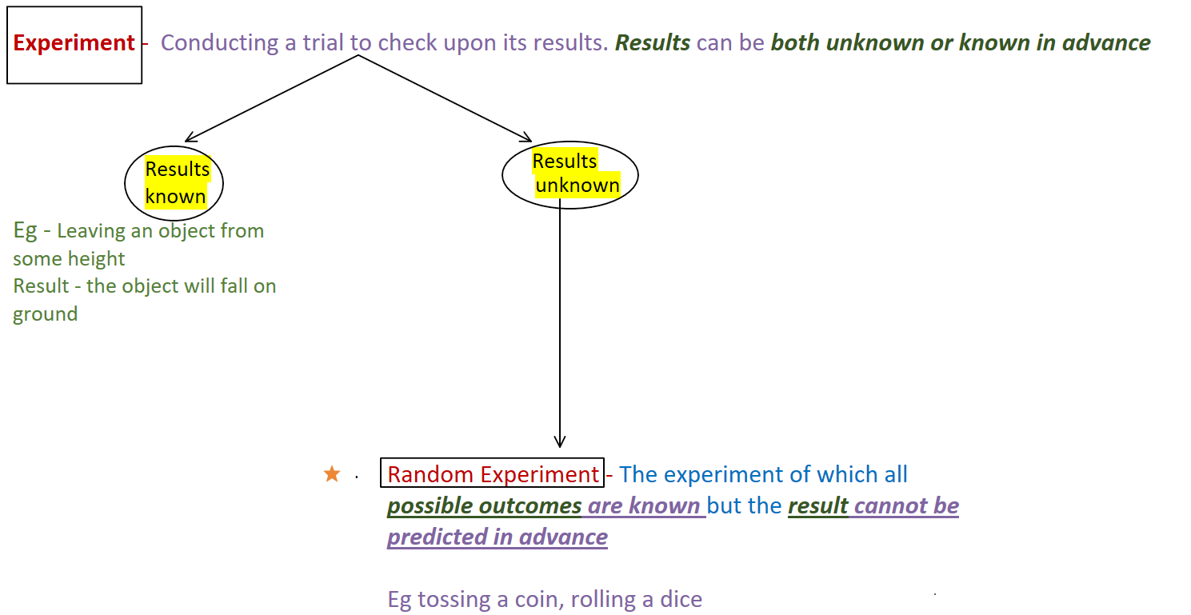

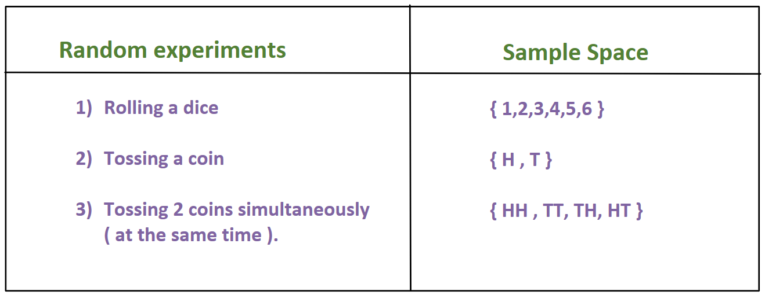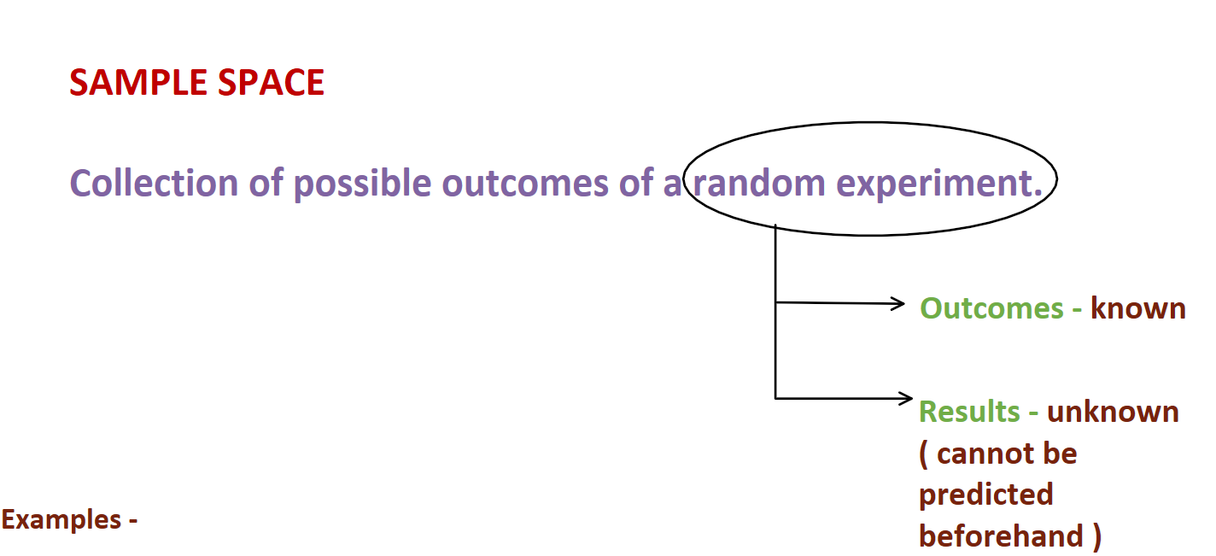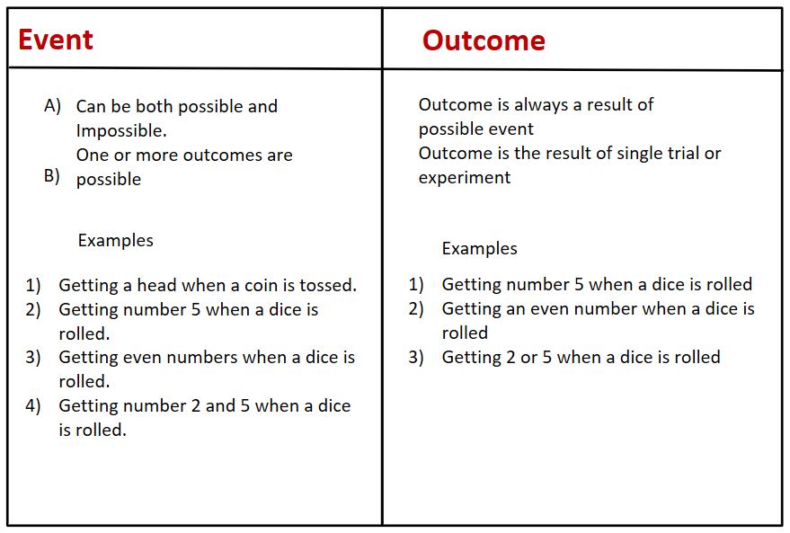

|  |  |  |  |  |  |
| --- | --- | --- | --- | --- | --- |
|  |  | HW - Reading of page 1 up to probability of an event and orange box on page 2. |  |  |  |
|  |  |  | |  |  |
|  |  |  |  |
|  |  |  |  |  |
|  |  | |  |  |  |
|  |  |  |  |